**On 2/24/22 geoduck early embryos (17 hours post fertilization) were dissociated and cells prepared for single-cell RNA sequencing. We targeted 24,000 cells (6000 cells across 4 10x reactions)**

**Protocol:** <https://drive.google.com/file/d/11NPtiYCqqYoyMRCKKaQFAobdUUjtXXn4/view?usp=share_link>

**Stage:** early gastrula? - that is what we were aiming for. There is not good information for Pacific geoduck on developmental timing in early development.

**Source:** fertilized eggs (pooled parents) were brought back to UW lab from Taylor hatchery on 2/23/22. Embryos were kept at 16C during transit and placed in 16C incubator until time of sampling.

**Images:** [**https://drive.google.com/drive/folders/1kFh6SLLr4kSG87KPF2P8MPMLWVwi0VGF?usp=share_link**](https://drive.google.com/drive/folders/1kFh6SLLr4kSG87KPF2P8MPMLWVwi0VGF?usp=share_link)

Check and see what you fixed in PFA

**Results:**

1. *Example of CellRanger output (1 of 4 replicate libraries)*

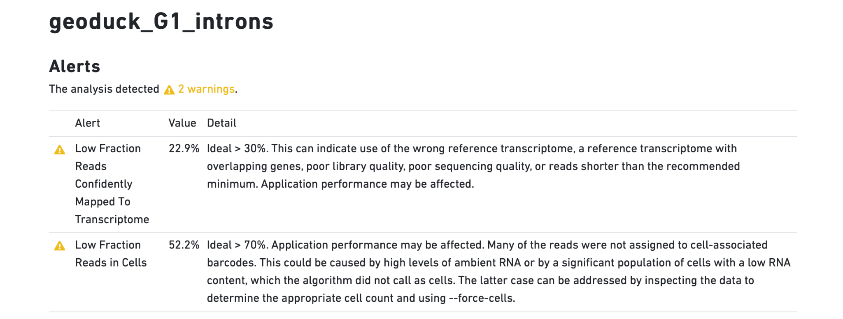

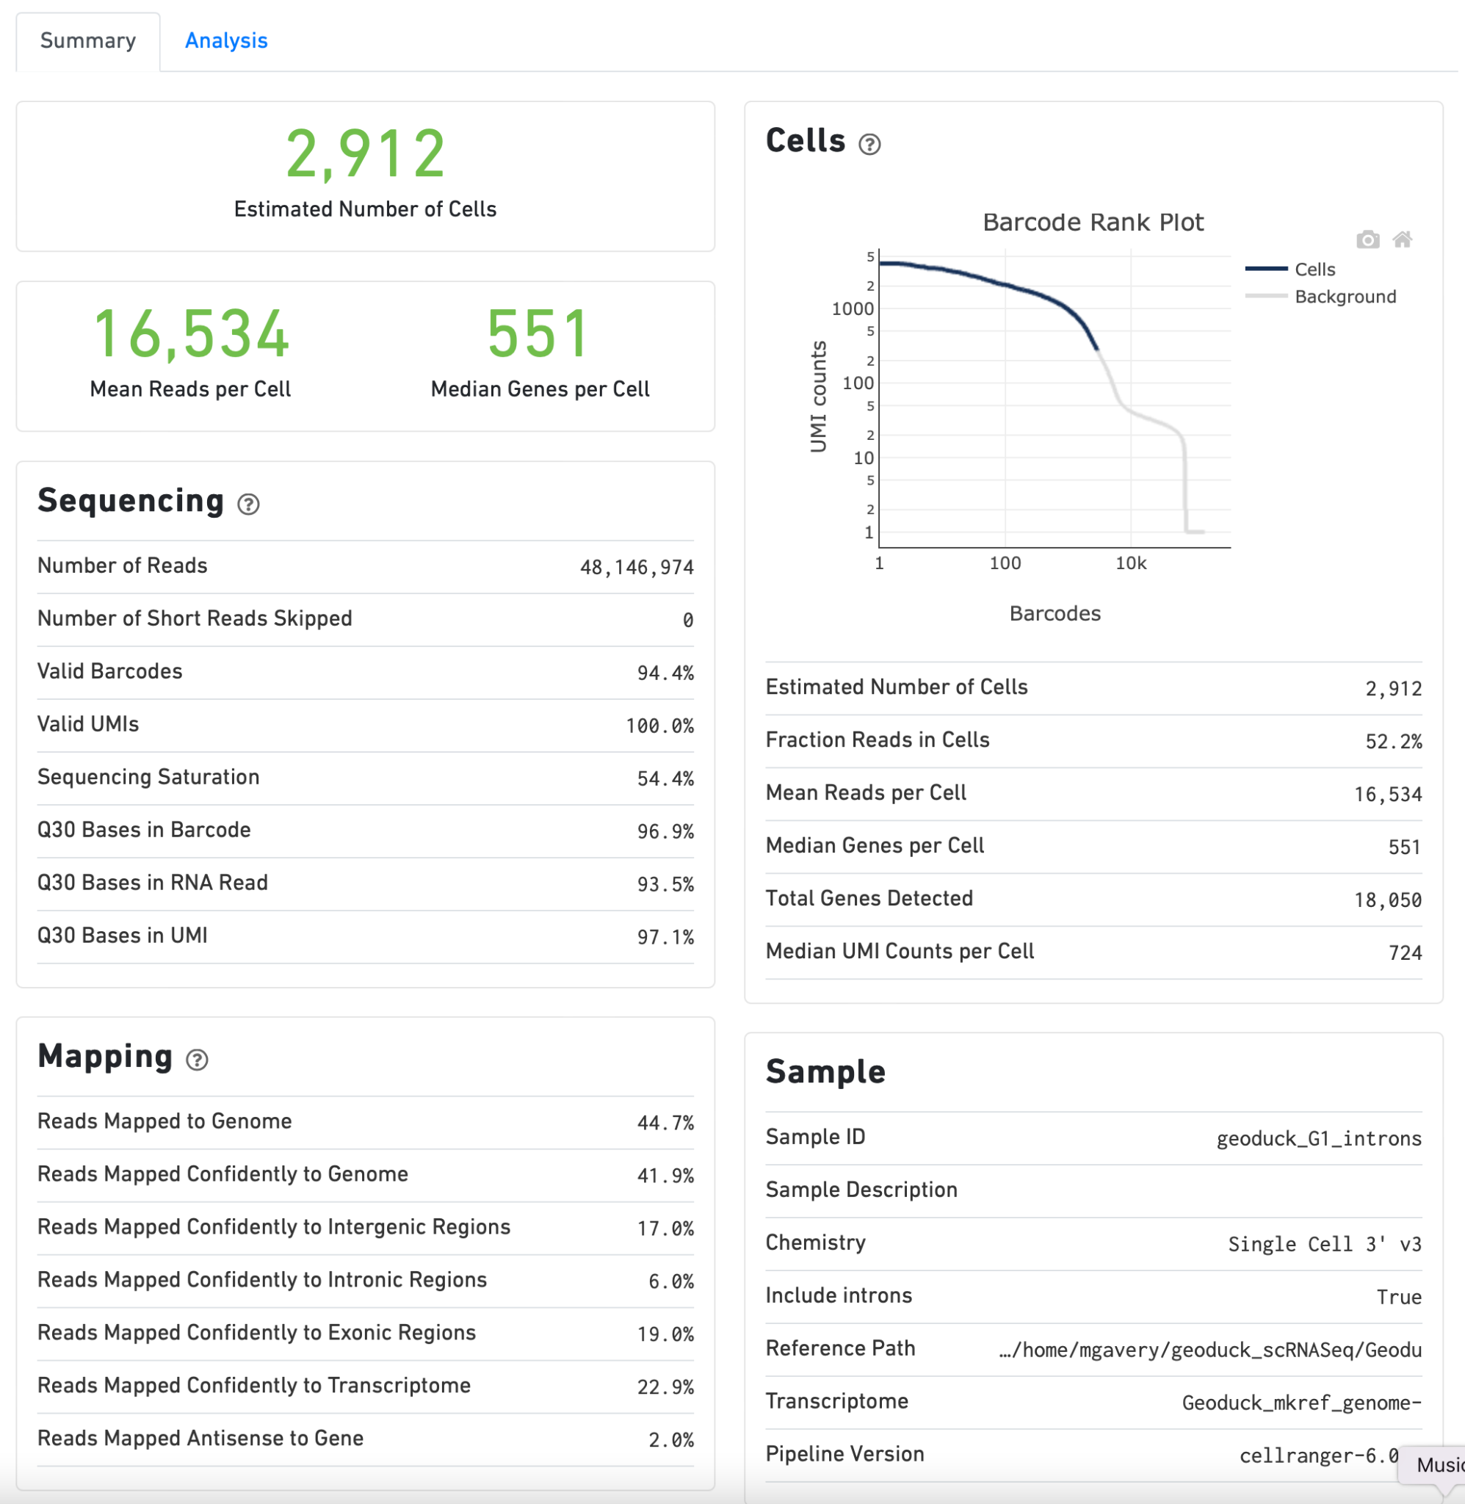

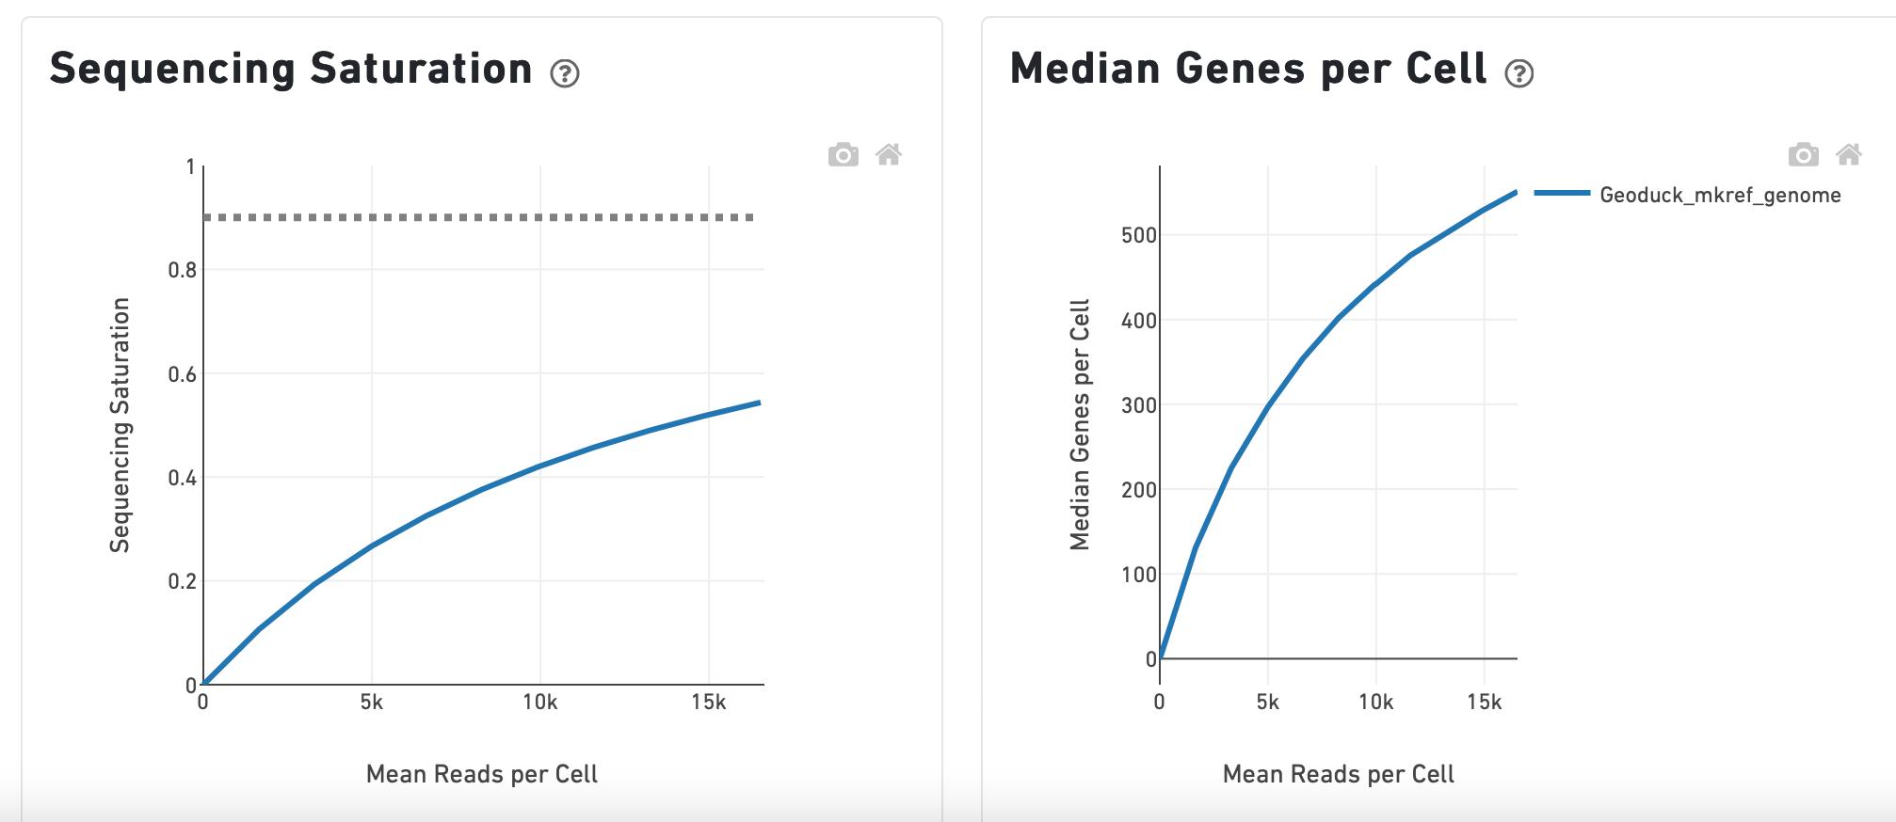

1. *Monocle3 output*

Number of cells (no additional filtering): 12,305

UMAP visualization - defaults used for “cluster cells”

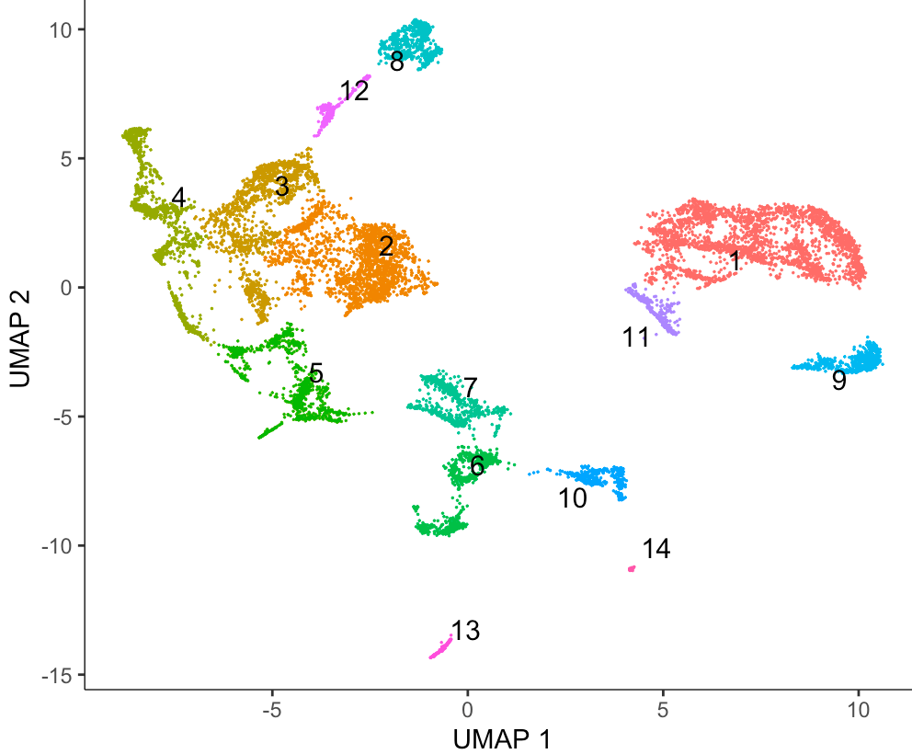

Expression pattern of vasa homolog

(vasa<-c("PGEN_.00g008080") #vasa<- c("LOC105335166") - 1e-43 evalue)

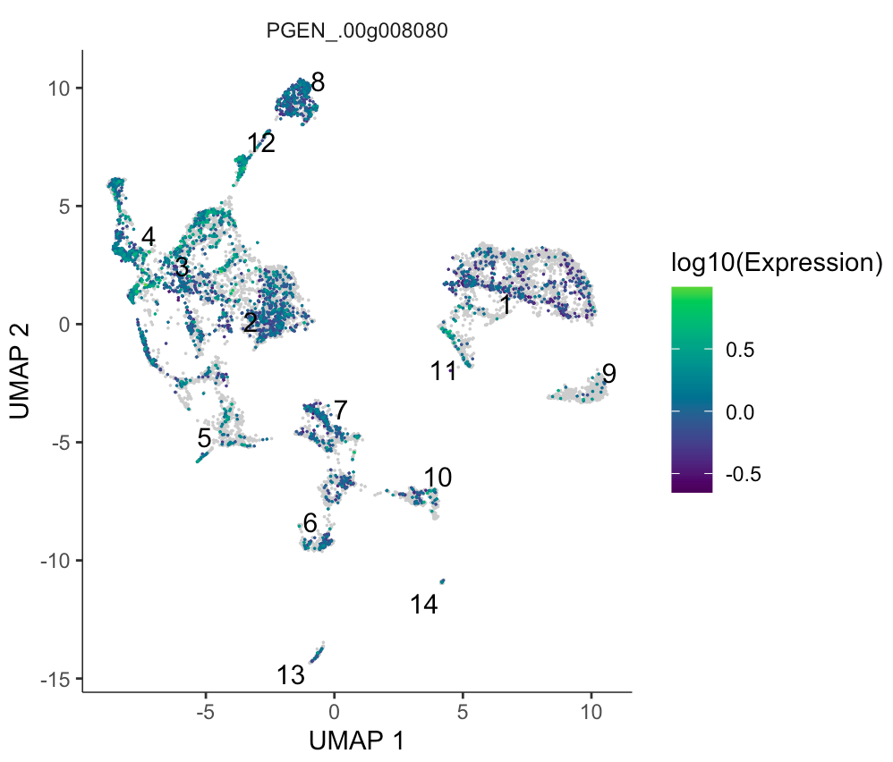

Expression patterns of sperm-specific histone homolog

sperm_histone_gene <- c("PGEN_.00g054930") #sperm_histone_gene <- c("LOC105327445")- 2e-8

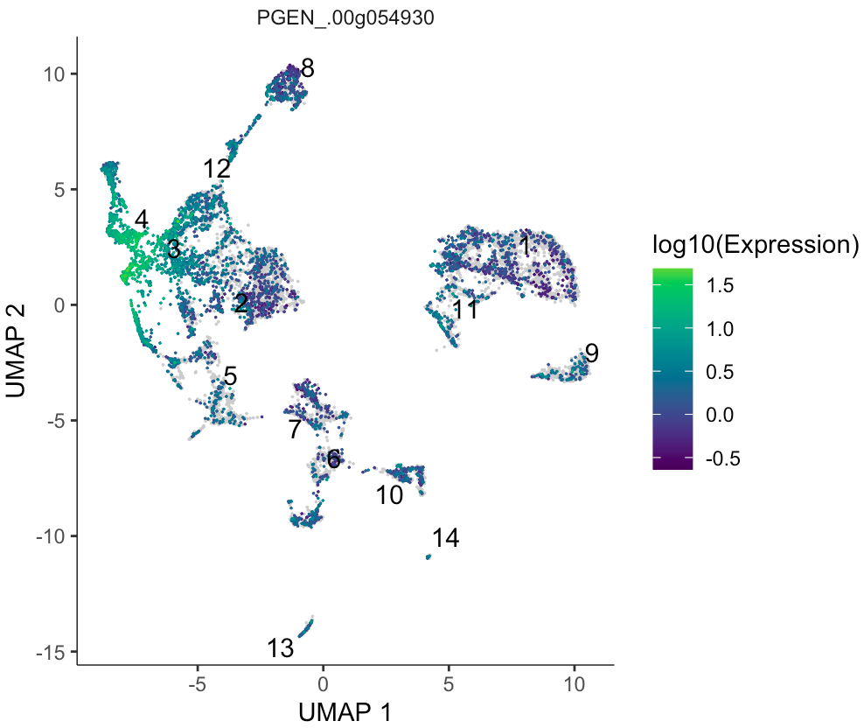

**Top Marker table for each cluster (with gigas annotation for comparison)**

<https://docs.google.com/spreadsheets/d/1hM1M2Ekx1_v11Vs5iF1TK9qyOWBNJ5DQ/edit?usp=share_link&ouid=102585373075410269597&rtpof=true&sd=true>